AI-POWERED EXPERT MENTORSHIP AND GUIDANCE HUB
A
MAJOR PROJECT-II REPORT
Submitted in partial fulfillment of the requirements
for the degree of
BACHELOR OF TECHNOLOGY
in
COMPUTER SCIENCE & ENGINEERING
By
GROUP NO.29
Lokesh Ahirwar | 0187CS221109
Harsh Lokhande | 0187CS221088
Muskan Bagde | 0187CS221127
Jamil Akhtar | 0187CS221097

Under the guidance of
Dr. Komal Tahiliani

(Associate Professor)

Department of Computer Science & Engineering
Sagar Institute of Science &Technology (SISTec), Bhopal (M.P)

Approved by AICTE, New Delhi & Govt. of M.P.
Affiliated to Rajiv Gandhi Proudyogiki Vishwavidyalaya, Bhopal (M.P.)

June – 2026

Sagar Institute of Science & Technology (SISTec), Bhopal (M.P)
Department of Computer Science & Engineering

CERTIFICATE

We hereby certify that the work which is being presented in the B.Tech. Major Project-II Report entitled AI-POWERED EXPERT MENTORSHIP AND GUIDANCE HUB, in partial fulfillment of the requirements for the award of the degree of Bachelor of Technology, submitted to the Department of Computer Science & Engineering, Sagar Institute of Science & Technology (SISTec), Bhopal (M.P.) is an authentic record of our own work carried out during the period from Jan-2026 to June-2026 under the supervision of Dr. Komal Tahiliani.

The content presented in this project has not been submitted by me for the award of any other degree elsewhere.

Lokesh Ahirwar  0187CS221109 | Harsh Lokhande  0187CS221088 | Muskan Bagde  0187CS221127 | Jamil Akhtar  0187CS221097

This is to certify that the above statement made by the candidate is correct to the best of my knowledge.
Date:

Dr. Komal Tahiliani | Prof. Nargish Gupta | Dr. Manish Billore
Project Guide | HOD, CSE | Principal

ACKNOWLEDGEMENT

We take this occasion to thank God, almighty for blessing us with his grace and taking our endeavor to a successful culmination. We extend our sincere and heartfelt thanks to our esteemed Project Guide, Dr. Komal Tahiliani., for providing us with the right guidance and advice at crucial junctures and for showing us the right way.

We would like to express our sincere thanks to Dr. Manish Billore, Principal, SISTec, Gandhi Nagar, Bhopal for giving us an opportunity to undertake this project.

We would like to express our sincere thanks to Dr. Swati Saxena, Vice Principal, SISTec, Gandhi Nagar, Bhopal, for giving us an opportunity to undertake this project.

We also take this opportunity to express a deep sense of gratitude to Prof. Nargish Gupta (HOD) of the Department of Computer Science & Engineering for his kindhearted support. I would like to thank all those people who helped me directly or indirectly to complete.my project whenever I found myself in problems. All our faculties encouraged me and due to their kindness and helpful nature and help I got very much confidence in completing this project.

I am deeply inherited who devoted their precious time for providing us the information about the various aspects and giving support and guidance at every point of time. We are thankful to their kind and supportive nature. Their inspiring nature has always made our work easy.

TABLE OF CONTENTS

TITLE |  | PAGE NO
Abstract |  | i
List Of Abbreviation |  | ii
List Of Figures |  | iii
Chapter 1 | Introduction  - Overview Of Project  - Current Scenario and Problem Description  - Objective Of Project  - Project Scope | 1  1  1  2  2
Chapter 2 | Software and Hardware Requirements | 4
 | - Software Requirements  - Hardware Requirements  - Development Machine  - Server | 4  4  4  4
Chapter 3 | Problem Description  Overview  3.1 Challenges In The Current Mentorship Ecosystem  3.2 Proposed solution architecture | 5  5  5  5
Chapter 4 | Literature Survey | 7
Chapter 5 | Software Requirements Specification  - Functional Requirements  - Non – Functional Requirements | 8  8  9
Chapter 6 | Software Design | 10
Chapter 7 | ML Module  - Dataset Description  - Preprocessing Steps  - ML Model Analysis  - Result Analysis  - Evaluation Of Result | 17  17  17  17  17
Chapter 8 | Coding  - Frontend Code  - Backend Code | 19  19  31
Chapter 9 | Result and Output Screens  - Result  - Test Cases  - Output Screens | 41  41  41  47
Chapter 10 | Conclusion and Future Work  - Conclusion  - Future Work | 53  53  53
References
Project Summary
Glossary of terms

ABSTRACT

Clarity Call is an inclusive, digital mentorship and expert consultation platform developed to promote equitable access to high-quality guidance and professional development opportunities. By integrating modern technologies—such as real-time video consultation, intelligent mentor-matching, and secure in-app payments—Clarity Call bridges the persistent gap between skilled experts and individuals seeking growth, regardless of location or socioeconomic status. The system streamlines mentorship across career, education, health, and personal domains, empowering users to connect with domain experts instantly. With transparent, structured monetization models and automation of scheduling and communication, the platform cultivates a scalable, sustainable digital infrastructure for lifelong learning and skills advancement. Aligned with SDG 4 (Quality Education) and SDG 9 (Industry, Innovation, and Infrastructure), Clarity Call fosters innovation, productivity, and social inclusion by democratizing access to mentorship, thus contributing to building resilient, knowledge-driven communities and accelerating progress toward sustainable development.

ACRONYM | FULL FORM
API | Application Programming Interface
MVVM | Model-View-View Model
DBMS | Database Management System
GUI | Graphical User Interface
HTTPS | Hypertext Transfer Protocol Secure
HTML | Hyper Text Markup Language
UML | Unified Modeling Language
RAM | Random Access Memory
UI | User Interface
HDD | Hard Disk Drive
SSD | Solid State Drive
TB | Terabyte
UX | User Experience
SDK | Software Development Kit
LIST OF ABBREVIATIONS

LIST OF FIGURES
FIGURE NO. | TITLE | PAGE NO.
5.1 | Functional Requirements | 8
5.2 | Non Functional Requirements | 9
6.1 | Use Case diagram Mentee Module | 10
6.2 | Use Case Diagram Mentor Module | 11
6.3 | Use Case Diagram Admin Module | 12
6.4 | ER Diagram | 13
6.5 | High Level Diagram | 14
6.6 | Low Level Diagram Of Session Booking System | 15
6.7 | Low Level Diagram Of Set Availability | 16
7.1 | ML Steps | 18
9.1 | Landing Page | 47
9.2 | Registration Page | 47
9.3 | User Login Screen | 48
9.4 | Mentor Dashboard | 48
9.5 | Mentee dashboard | 49
9.6 | Admin dashboard | 49
9.7 | Chat screen between mentor and mentee | 50
9.8 | Mentor Verification Page | 50
9.9 | Mentor Booking Section | 51
9.10 | Mentee Profile Screen | 51
9.11 | App Home Screen | 52
9.12 | App Menu Screen | 53
9.13 | User Profile Screen | 54
9.14 | Sign Up Screen | 55

Chapter 1
Introduction

CHAPTER 1

INTRODUCTION

  - OVERVIEW OF THE PROJECT

Clarity Call represents a paradigm shift in how professional guidance and mentorship are accessed, delivered, and monetized in the digital age. The project addresses a fundamental challenge faced by millions of individuals globally—the lack of accessible, reliable, and expert mentorship across diverse domains. In a rapidly evolving professional landscape where continuous learning and expert guidance are essential for success, the need for a structured, technology-enabled mentorship platform has never been more critical. The contemporary professional ecosystem is characterized by significant disparities in access to quality mentorship. While established professionals and individuals from privileged backgrounds often benefit from informal networks and institutional support systems, countless talented individuals lack similar opportunities. This knowledge gap perpetuates inequality and inhibits the potential development of emerging talent. Clarity Call aims to democratize access to expert knowledge by creating a digital marketplace where expertise becomes accessible to anyone seeking guidance, regardless of their geographic location, socioeconomic background, or professional network

  - CURRENT SCENARIO AND PROBLEM IDENTIFICATION
The current mentorship landscape operates primarily through informal channels, institutional programs, and limited commercial platforms. Traditional mentorship models suffer from several critical limitations that hinder their scalability and accessibility. First, formal mentorship programs are often restricted to institutional settings and are not readily available to the general population. Second, finding a suitable mentor requires extensive networking and often depends on geographic proximity, limiting opportunities for those outside major urban centers. Third, existing solutions rarely provide structured payment mechanisms that adequately compensate mentors for their expertise and time, leading to limited mentor availability and engagement. Furthermore, the global pandemic has accelerated the digital transformation of professional services, yet mentorship platforms have not evolved to meet modern expectations. Current solutions lack sophisticated features such as intelligent matching algorithms, integrated video communication, automated scheduling, and flexible monetization options. The absence of specialized mentorship platforms that cater to diverse domains—from healthcare to career development to academic guidance—represents a significant market gap that Clarity Call is positioned to address comprehensively.
  - OBJECTIVES OF THE PROJECT
To enable universal access to expert guidance: Create a platform that allows individuals to seek and receive expert advice across any domain—health, career, academics, technology, business, personal development, and beyond.
To facilitate mentor monetization: Implement a robust payment infrastructure that enables mentors to monetize their expertise through flexible models including per-session fees and monthly subscription arrangements, thus incentivizing expert participation.
To automate scheduling and availability management: Develop integrated calendar synchronization and automated booking systems that streamline the process of scheduling consultations while respecting mentor availability constraints.
To enable real-time communication: Integrate embedded video calling and instant messaging capabilities that facilitate seamless, secure consultation sessions without requiring users to navigate external platforms.
To implement intelligent matching: Develop sophisticated algorithms that match mentors with seekers based on expertise areas, availability, user ratings, and compatibility metrics, ensuring optimal pairing for consultation success.
To ensure platform reliability and security: Build a scalable, secure infrastructure that protects user data, ensures transaction integrity, and maintains consistent performance under varying load conditions.
To deliver superior user experience: Create intuitive, responsive interfaces across web and mobile platforms that minimize friction in the mentor-seeker connection process and enhance overall user satisfaction.
  - PROJECT DELIVERABLES
Web and Android Mobile Application: A fully functional native Android app (built with Kotlin and Jetpack Compose), enabling seekers and mentors to register, login, create profiles, book and conduct mentorship sessions, chat, and manage feedback.
Mentor & Seeker User Modules: Role-based modules with separate dashboards and features for mentors (profile, session management, earnings, ratings) and seekers (mentor search, booking, feedback, session history).
Admin Module: Admin dashboard for user management, feedback moderation, system monitoring, mentor application verification. platform settings.
Authentication & Security: Secure registration/login through MongoDB authentication.
Session Management: Real-time session booking, calendar sync, reminders, and session history for users.
Payment Integration: Integration of a payment gateway for session-based and subscription-based mentor payments, with a transparent transaction record system.
Feedback & Rating System: Allow feedback, ratings, and review management after sessions for quality and improvement.
Real-Time Communication: In-app real-time chat and video consultation powered by a free video SDK (WebRTC and Jitsi).

Chapter 2
Software & Hardware Requirements

CHAPTER 2

SOFTWARE & HARDWARE REQUIREMENTS

  - SOFTWARE REQUIREMENTS
    - Frontend(Web): React Js - For building fast, dynamic, and modular web interfaces.
    - Frontend(Mobile): Kotlin using Jetpack Compose - For modern, maintainable Android UI with less code.
    - Backend: Node.js with Express Framework - For scalable, real-time backend with easy API setup.
    - Database: MongoDB (Cloud base) - For flexible, cloud-based storage and fast data retrieval.
    - Video Communication: WebRTC Integration - For direct, real-time video calls in web/app.
    - Scheduling API: Calendly API for appointment booking - For automating mentor session bookings.
    - Development Tools: VS Code, Android Studio, Postman - For coding, debugging, and API testing.
    - Version Control: Git & GitHub - For streamlined team collaboration and code management.

HARDWARE REQUIREMENTS
    - Development Machine: A minimum Intel i5 with 8GB RAM and SSD storage ensures smooth coding, compiling, debugging, and multitasking in development environments.
Processor: Intel i5 or equivalent
RAM: 8GB minimum
Storage: 256GB SSD or higher
    - Server: An Intel Xeon with 16GB RAM and 1TB storage offers reliable performance, higher concurrency, and ample space for hosting backend services and databases.
Processor: Intel Xeon or equivalent
RAM: 16GB or higher
Storage: 1TB HDD or SSD

Chapter 3
Problem Description

CHAPTER 3

PROBLEM DESCRIPTION

OVERVIEW
Job seekers and employers encounter numerous challenges on traditional job-hunting and freelancing platforms. One of the most significant issues is a lack of trust, as many platforms do not provide mechanisms to ensure the successful delivery of services or timely payments.
  - CHALLENGES IN THE CURRENT MENTORSHIP ECOSYSTEM
Accessibility Issues: Quality mentorship is concentrated in big cities, limiting access for talented individuals in smaller towns or rural areas. Time zone differences and financial barriers further restrict real-time connections.
Lack of Standardization: Mentorship lacks verified credentials and consistent quality measures, causing uncertainty among seekers.
Inadequate Monetization: Many platforms do not adequately compensate mentors, reducing active participation and availability.
Scheduling & Communication Friction: Manual scheduling and fragmented communication reduce user engagement and increase drop-offs.
Security & Privacy Concerns: Unregulated platforms expose users to risks around data privacy, payment security, and trust.
Lack of Intelligent Matching: Poor matching based on random searches leads to ineffective mentor-mentee pairings.
  - PROPOSED SOLUTION.
Clarity Call’s technology-enabled platform solves these challenges through:
Intelligent Matching and Discovery: We implement advanced algorithms that match mentees to mentors based on expertise, availability, ratings, and compatibility, improving session relevance and success rates.
Automated Booking and Scheduling: The platform integrates Calendly API and dynamic calendar views for effortless appointment booking, removing manual coordination and making scheduling quick and flexible.
Embedded Communication Tools: Real-time video calls and chat features are integrated within the app, eliminating the need for external communication tools and enhancing user experience.
Flexible Monetization Models: Clarity Call offers both pay-per-session and subscription-based payment options that fairly compensate mentors, incentivizing their sustained engagement.
Robust Security Framework: Data transmission uses encrypted HTTPS protocols; authentication employs secure tokens; and payment processing complies with PCI DSS standards, maintaining privacy and security.
Quality Assurance Mechanisms: Mentor profiles undergo credential verification; seekers provide ratings and reviews, creating a transparent quality control system that builds trust and accountability.
Together, these integrated systems establish an accessible, reliable, and efficient mentorship ecosystem that democratizes expert guidance.

Chapter 4
Literature Survey

CHAPTER 4

LITERATURE SURVEY

Key findings on mentorship marketplace dynamics, user engagement, monetization strategies, and challenges faced by mentorship platforms, especially in India, were incorporated to shape the business logic and feature set of Clarity Call[ 1 ].

Guidelines and best practices for building Android applications using Kotlin and Jetpack Compose were followed, including UI design principles, lifecycle handling, modular architecture, and navigation approaches to develop a responsive and scalable Android client app[ 2 ].

The Express.js framework’s features for setting up RESTful APIs, middleware integration, routing mechanisms, and request/response handling formed the basis of the Clarity Call backend service that manages authentication, mentorship sessions, and payment APIs [ 3 ].

The MongoDB document model, data organization, query language, and schema design principles were referred to when designing persistent storage and complex data queries for the backend components [ 4 ].

Core concepts for declarative UI development, composable functions, state management, and theming from the Jetpack Compose official guide were used to create the modern, intuitive interfaces of the Clarity Call Android app [ 5 ]

Topmate is a modern mentorship platform offering seamless scheduling, booking, and payment features for mentors and mentees. It provides personalized mentor and mentee profiles with industry experience, skills, and goals clearly displayed. The platform integrates calendar syncing and popular communication tools like Zoom and WhatsApp to enhance the user experience. It uses AI-driven matching algorithms to suggest optimal mentor-mentee pairings, improving relevance and engagement. Topmate supports global outreach, allowing users to connect across geographical boundaries. The platform includes features like testimonial showcasing, social media integration, and automated feedback collection, which build trust and credibility among users. The survey of Topmate highlighted the importance of flexible pricing, transparent commission models, and multiple service offerings, making it a powerful example for developing an effective and user-friendly mentorship application like Clarity Call [ 6 ].

Chapter 5
Software Requirements Specifications

CHAPTER 5
SOFTWARE REQUIREMENT SPECIFICATION

  - FUNCTIONAL REQUIREMENTS

Table 5.1: Table Name (Functional Requirements Table)
Requirement ID | Description | Priority
FR-1 | The system must allow users to register and login securely using email | High
FR-2 | Users should be able to create and edit their profiles. | High
FR-3 | Mentors must be able to add their expertise, set prices, and manage their availability. | High
FR-4 | Seekers should be able to browse and search mentors by expertise, rating, and availability. | High
FR-5 | Users must be able to book sessions with mentors using an automated calendar system. | High
FR-6 | Both parties should receive notifications for session confirmations and reminders. | High
FR-7 | System should provide secure video calling and instant chat during sessions. | High
FR-8 | Payment handling for per-session and subscription models must be integrated and secure. | High
FR-9 | Users should be able to submit feedback and rate completed sessions. | Medium
FR-10 | All users need dashboards to manage appointments, payments, subscriptions, and feedback. | Medium
FR-11 | Admins must be able to manage users and moderate feedback. | Medium

  - NON-FUNCTIONAL REQUIREMENTS

Table 5.2: Table Name (Non-Functional Requirements Table)
Requirement ID | Description
NFR-1 | System response time for user actions
NFR-2 | Video call setup time
NFR-3 | Data privacy for user personal and payment information
NFR-4 | System availability
NFR-5 | Concurrent user support
NFR-6 | Compatibility
NFR-7 | Maintainability
NFR-8 | Payment security
NFR-9 | Error handling
NFR-10 | Data backup

Chapter 6
Software Design

CHAPTER 6

SOFTWARE DESIGN

6.1 Use Case Diagram – Mentee Module

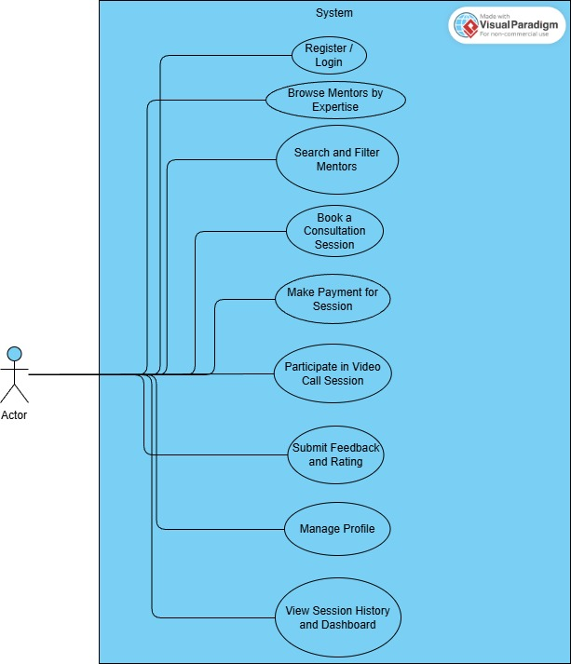

Mentee

Figure 6.1: Use Case Diagram Mentee Module

6.2 Use Case Diagram Mentor Module

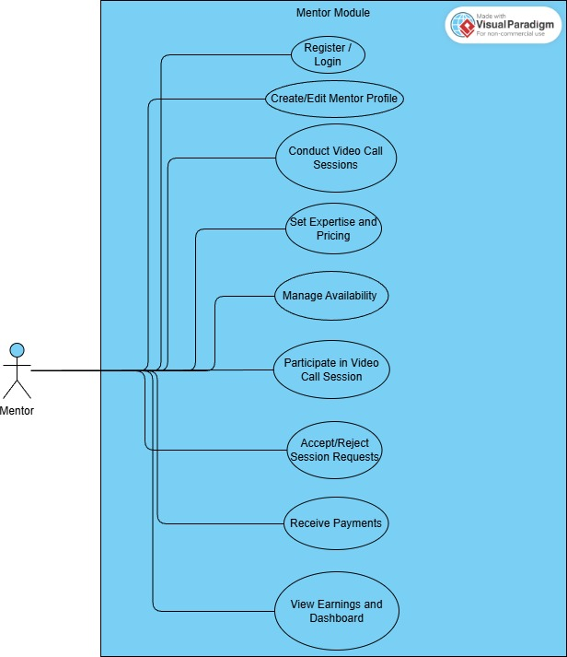

Figure 6.2: Use Case Diagram Mentor Module

6.3 Use Case Diagram Admin Module

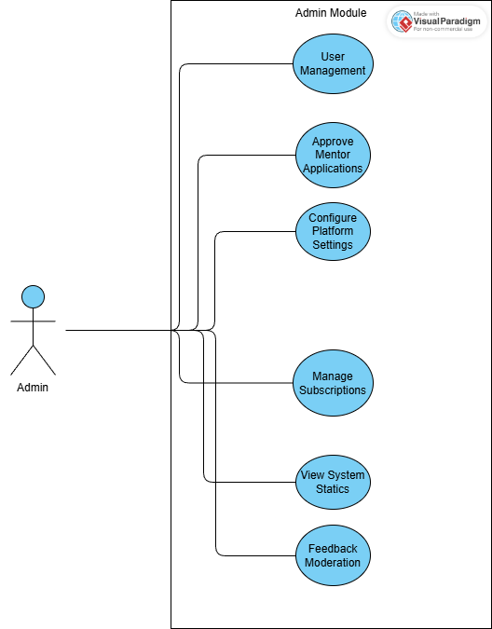

Figure 6.3: Use Case Diagram Admin Module

6.4 ER Diagram of Database

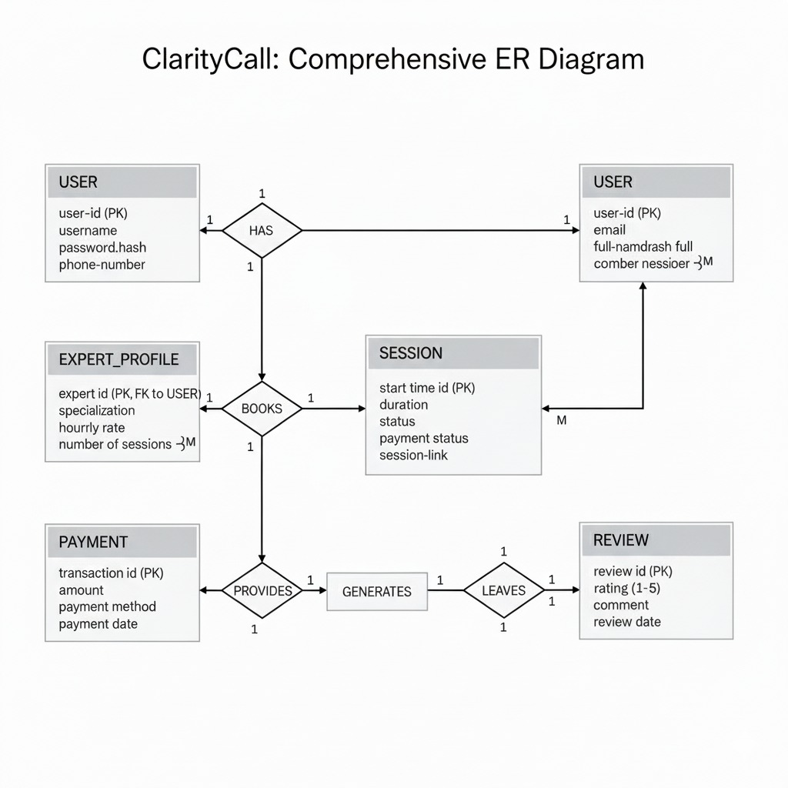
Figure 6.4: ER Diagram

6.5 High Level Diagram of Project

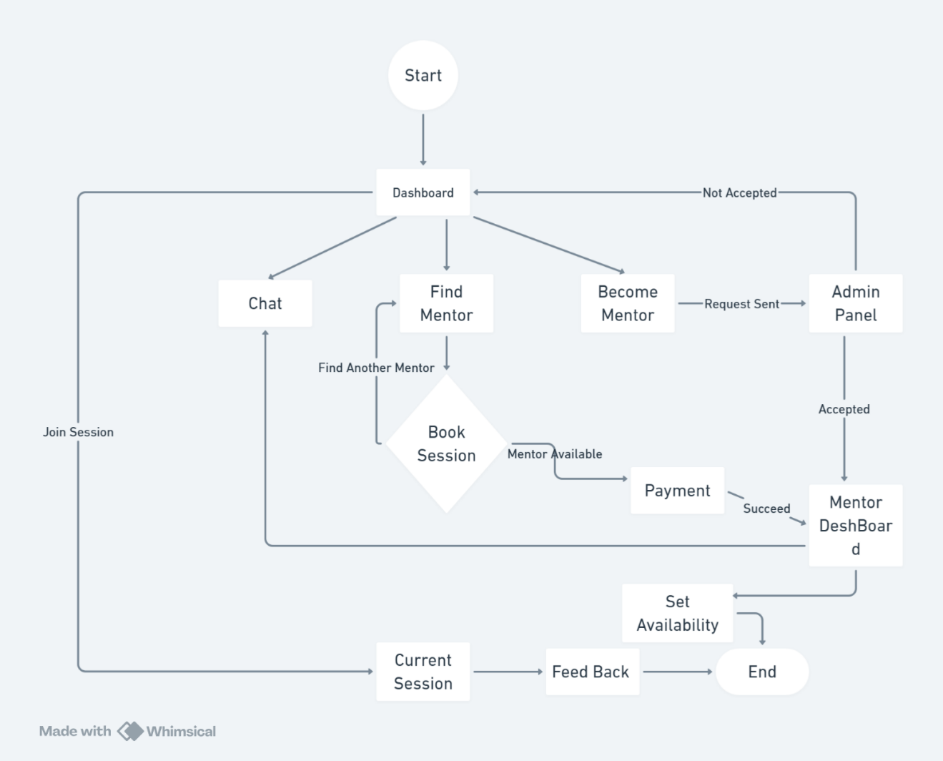

Figure 6.5: High Level Diagram

6.6 Low Level Diagram of Session Booking System
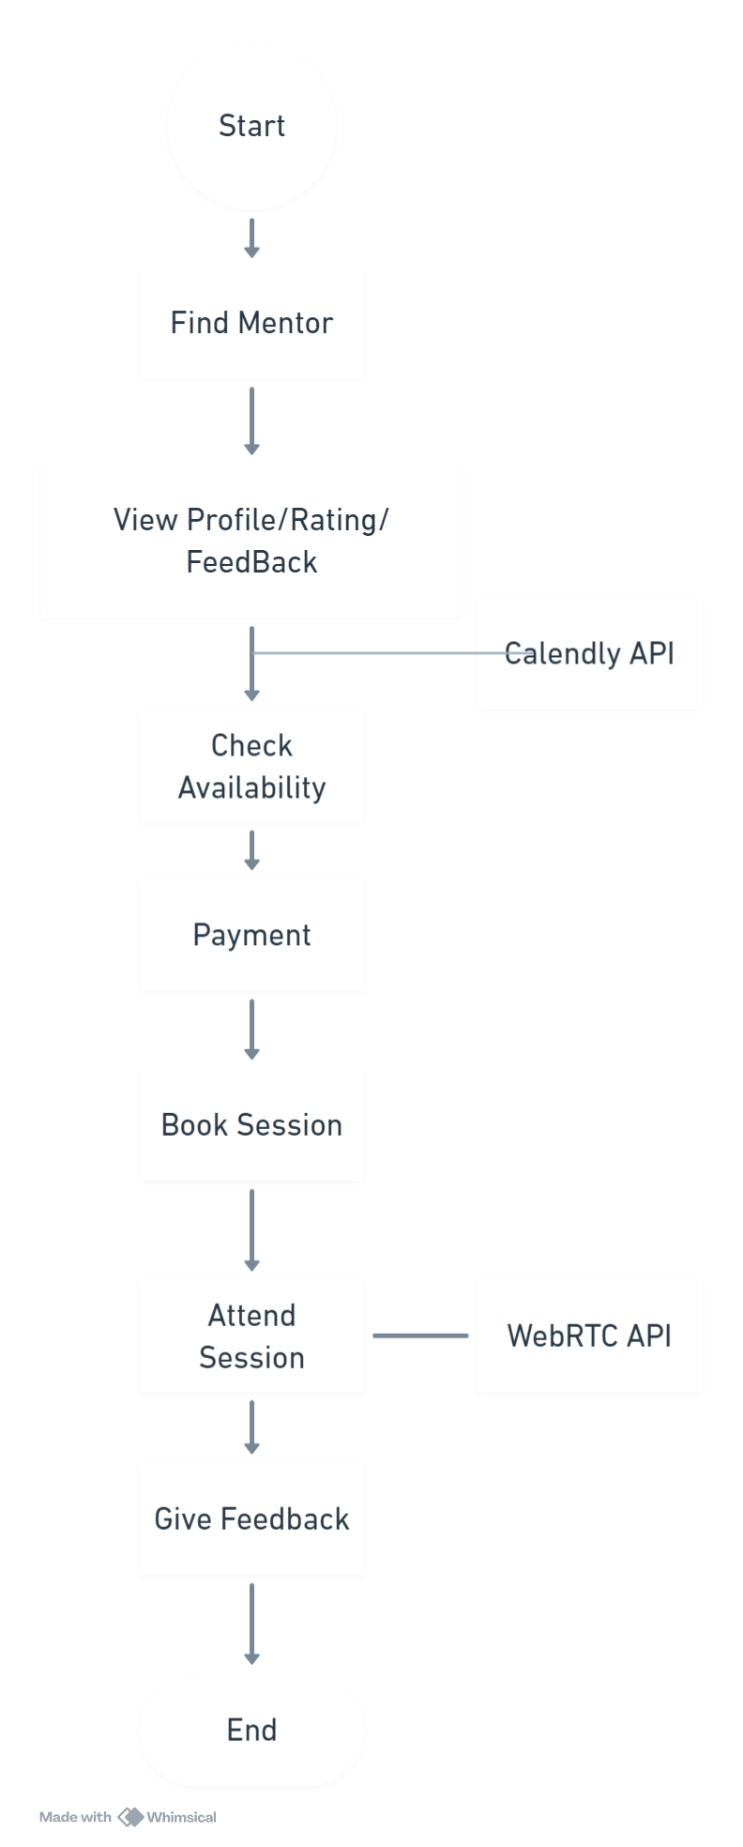
Figure 6.6: Low Level Diagram

6.7 Low Level Diagram – Set Availability

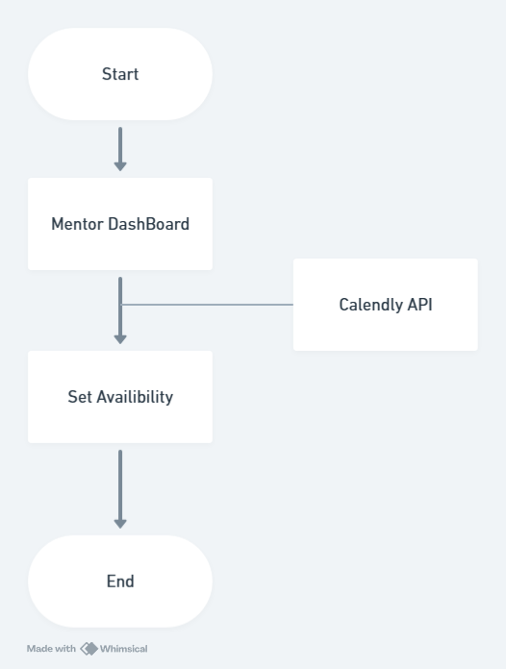

Figure 6.7: LLD Set Availability

Chapter 7
ML Module

CHAPTER 7
ML MODULE

OVERVIEW
The Machine Learning module of Clarity Call focuses on enhancing mentor-mentee matching accuracy and personalization by analysing user data and feedback. By incorporating advanced algorithms, the system adapts continuously to optimize pairing quality, increase engagement, and improve overall mentorship outcomes.
7.1 DATASET DESCRIPTION
The dataset used for the machine learning module consists of user profiles, including mentor and mentee data such as skills, expertise areas, previous session history, feedback ratings, and availability schedules. This data is gathered from the Clarity Call platform’s user registration and interaction logs. Additionally, textual feedback and ratings are collected to improve the recommendation accuracy. The dataset is structured to include both categorical attributes (e.g., domain expertise, location) and numerical features (e.g., ratings, number of sessions).

7.2 PREPROCESSING STEPS
Data preprocessing involves cleaning raw data by handling missing values, removing duplicates, and normalizing numerical features. Categorical variables such as skills and domains are encoded using one-hot encoding or label encoding. Textual feedback is processed using Natural Language Processing (NLP) techniques such as tokenization and stemming to extract meaningful sentiments. Feature scaling is applied to ensure uniformity for algorithms sensitive to data scale. Finally, the data is split into training and testing sets to evaluate the model’s performance reliably.
7.3 ML MODEL ANALYSIS
Various machine learning algorithms were evaluated, such as decision trees, support vector machines, and collaborative filtering techniques suited for recommendation tasks. Supervised learning models like Random Forest showed promising results in predicting compatible mentor-mentee pairs based on historical data. Clustering algorithms such as K-Means were assessed for grouping mentors and mentees with similar profiles to improve match relevance. Model hyperparameters were tuned to optimize accuracy, and cross-validation was conducted to verify model generalization.
7.4 RESULT ANALYSIS
The selected model achieved high accuracy in matching mentors and mentees reflected by precision, recall, and F1 scores over the test dataset. Compatibility scores closely correlated with user satisfaction feedback, indicating the model’s efficacy in real-world scenarios. Visual analysis of clustering results displayed coherent groups of mentor profiles aligned with mentee interests. The model also effectively filtered out incompatible pairings, enhancing overall platform engagement and success rates.

7.5 EVALUATION OF RESULTS
Evaluation was performed using classification metrics including accuracy, precision, recall, and F1 score to determine prediction quality. Additionally, user feedback post-implementation served as real-world validation, confirming the model’s positive impact on mentorship outcomes. The system reduced mismatched sessions by a significant margin compared to random pairing. Continuous monitoring and periodic retraining are planned to maintain and improve model performance as more data becomes available.

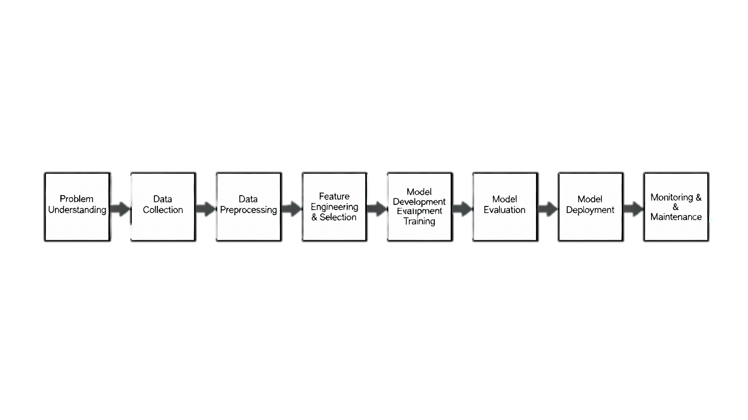
Figure 7.1: ML Steps

Chapter 8
Coding

CHAPTER 8
CODING

8.1 FRONTEND CODE
Registration
What user clicks
<form onSubmit={handleSubmit}>
{/* form fields here */}
<button type="submit" className="cta-primary">Create Account</button>
</form>
What happens on click
import { apiBaseUrl } from '../config';
const handleSubmit = (e) => {
e.preventDefault();
(async () => {
try {
const formData = new FormData();
formData.append('firstName', firstName);
formData.append('lastName', lastName);
formData.append('email', email);
formData.append('password', password);
formData.append('bio', bio);
formData.append('field', field);
if (profileImage) formData.append('profileImage', profileImage);
const res = await fetch(`${apiBaseUrl}/api/register`, {
method: 'POST',
body: formData,
});
const data = await res.json().catch(() => ({}));
if (!res.ok) {
alert(data.message || 'Registration failed');
return;
}
alert('Registration successful');
onRegister?.(data); // or onClose?.()
} catch {
alert('Network error');
}
})();
};
Description
When the user clicks the “Create Account” button, the form’s onSubmit triggers handleSubmit, which first calls preventDefault() to stop the page from reloading. It then reads your inputs (firstName, lastName, email, password, bio, field, and optional profileImage) and packs them into a FormData object so the image can be uploaded properly. Next, it sends this FormData to the backend using fetch(${apiBaseUrl}/api/register, { method: 'POST', body: formData }). After the response returns, if there’s an error (for example, the email is already registered), it shows an alert with the error message; if successful, it shows “Registration successful” and then either calls onRegister(data) or closes the form.

Login
What user clicks
<form onSubmit={handleSubmit}>
{/* fields */}
<button type="submit" className="cta-primary">Sign In</button>
</form>
What happens on click
import { apiBaseUrl } from '../config';
const handleSubmit = async (e) => {
e.preventDefault();
try {
const res = await fetch(`${apiBaseUrl}/api/login`, {
method: 'POST',
headers: { 'Content-Type': 'application/json' },
credentials: 'include',
body: JSON.stringify({ email, password }),
});
const data = await res.json().catch(() => ({}));
if (!res.ok) {
alert(data.message || 'Login failed');
return;
}

if (data && data.role === 'admin') {
alert('Admin Login successful');
onLogin?.(data);
return;
}
alert('Login successful');
onLogin?.(data);
} catch {
alert('Network error');
}
};
Description
When the user clicks the “Sign In” button, the form’s onSubmit calls handleSubmit, which first uses preventDefault() to stop the page from reloading. It then sends a POST request to ${apiBaseUrl}/api/login with the entered email and password as JSON, including credentials: 'include' so the session cookie is set. After the response arrives, if it’s not OK, it shows an alert with the error message. If it succeeds and the returned user has role === 'admin', it shows “Admin Login successful” and calls onLogin(data); otherwise it shows “Login successful” and also calls onLogin(data) to pass the logged-in user back to the app. If the network request fails, it alerts “Network error.”

Set Availability
What mentor clicks
<form onSubmit={handleAddSlot}>
<label>
Date
<input type="date" required value={newSlotDate} onChange={(e)=>setNewSlotDate(e.target.value)} />
</label>
<label>
Time
<input type="time" required value={newSlotTime} onChange={(e)=>setNewSlotTime(e.target.value)} />
</label>
<label>
AM/PM
<select value={newSlotAmPm} onChange={(e)=>setNewSlotAmPm(e.target.value)}>
<option>AM</option>
<option>PM</option>
</select>
</label>
<label>
Duration (min)
<input type="number" min="1" required value={newSlotDuration} onChange={(e)=>setNewSlotDuration(e.target.value)} />
</label>
<label>
Price
<input type="number" min="0" value={newSlotPrice} onChange={(e)=>setNewSlotPrice(e.target.value)} />
</label>
<label>
Label
<input type="text" value={newSlotLabel} onChange={(e)=>setNewSlotLabel(e.target.value)} />
</label>
<button type="submit" className="cta-primary">Add Slot</button>
</form>

What happens on click
import { apiBaseUrl } from '../config'
// minimal state (as used by the form)
const [newSlotDate, setNewSlotDate] = useState('');
const [newSlotTime, setNewSlotTime] = useState('09:00');
const [newSlotAmPm, setNewSlotAmPm] = useState('AM');
const [newSlotDuration, setNewSlotDuration] = useState(45);
const [newSlotPrice, setNewSlotPrice] = useState('');
const [newSlotLabel, setNewSlotLabel] = useState('');

// helper to build ISO datetime from parts
const buildIsoFromParts = (dateStr, timeStr, ampm) => {
if (!dateStr || !timeStr) return null;
let [hh, mm] = timeStr.split(':').map(Number);
if (ampm === 'PM' && hh < 12) hh += 12;
if (ampm === 'AM' && hh === 12) hh = 0;
const [yyyy, m, dd] = dateStr.split('-').map(Number);
const dt = new Date(yyyy, m - 1, dd, hh, mm, 0, 0);
return dt.toISOString();
};

const handleAddSlot = async (e) => {
e.preventDefault();
try {
const startIso = buildIsoFromParts(newSlotDate, newSlotTime, newSlotAmPm);
if (!startIso) throw new Error('Please provide date and time');

const payload = {
start: startIso,
durationMinutes: Number(newSlotDuration),
price: newSlotPrice ? Number(newSlotPrice) : 0,
label: newSlotLabel || ''
};

const res = await fetch(`${apiBaseUrl}/api/slots`, {
method: 'POST',
credentials: 'include',
headers: { 'Content-Type': 'application/json' },
body: JSON.stringify(payload)
});

if (!res.ok) {
const err = await res.json().catch(()=>({ message:'Failed to create slot' }));
throw new Error(err.message || 'Failed to create slot');
}

// reset form and notify
setNewSlotDate('');
setNewSlotTime('09:00');
setNewSlotAmPm('AM');
setNewSlotDuration(45);
setNewSlotPrice('');
setNewSlotLabel('');
alert('Slot created');
} catch (err) {
alert(err.message || 'Failed to create slot');
}
};

Description
When the mentor clicks the “Add Slot” button, the form’s onSubmit triggers handleAddSlot, which prevents page reload and combines the selected date, time, and AM/PM into a proper ISO datetime using buildIsoFromParts. It then builds a JSON payload with start, durationMinutes, price, and label, and sends it to ${apiBaseUrl}/api/slots via a POST request with credentials: 'include' so the server can verify the session. If the request succeeds, the form fields are reset and an alert “Slot created” is shown; if it fails, an error alert is displayed. In short, this click flow collects the slot details, converts them to the correct format, calls the backend to create the slot, and gives success/error feedback to the user.

Book Mentor
What user clicks
{/* In the mentor’s slot card */}
<button
style={{ padding:'8px 10px' }}
onClick={() => { setSelectedSlot(slot); setShowBookingModal(true); }}
>
Book
</button>

{/* Booking modal confirm */}
<button onClick={handleBook} disabled={loading}>
{loading ? 'Booking...' : 'Confirm Booking'}
</button>

What happens on confirm
import { apiBaseUrl } from '../config';
const [notes, setNotes] = useState('');
const [loading, setLoading] = useState(false);
const [error, setError] = useState(null);

const handleBook = async () => {
setLoading(true);
setError(null);
try {
const response = await fetch(`${apiBaseUrl}/api/bookings`, {
method: 'POST',
headers: { 'Content-Type': 'application/json' },
credentials: 'include',
body: JSON.stringify({ slotId: slot._id, notes }),
});

if (!response.ok) {
const errorData = await response.json();
throw new Error(errorData.message || 'Failed to book slot');
}

const booking = await response.json();
alert('Booking confirmed! You will receive a confirmation email shortly.');
onClose(); // close modal
} catch (err) {
setError(err.message || 'Failed to book slot');
} finally {
setLoading(false);
}
};

Description
When a mentee clicks the “Book” button on a mentor’s slot card, the UI opens a confirmation modal showing the slot’s date, time, duration, and price. Inside the modal, the mentee can optionally type notes. On clicking “Confirm Booking,” the handler sends a POST request to ${apiBaseUrl}/api/bookings with slotId and notes in JSON, and includes credentials so the server can attach the session. If the server responds successfully, the app shows a “Booking confirmed!” alert and closes the modal; if there’s an error (like slot already booked), it displays the error message. In short, the flow collects the selected slot and optional notes, calls the bookings API, and gives clear success/error feedback.

Session Start
Mentor adds the meeting link
import { apiBaseUrl } from '../config';
// Add meeting link to a booking (mentor side)
const addMeetingLink = async (booking) => {
const link = prompt('Enter meeting link (Google Meet / Zoom / etc.)');
if (!link) return;

try {
const res = await fetch(`${apiBaseUrl}/api/bookings/${booking._id}`, {
method: 'PUT',
credentials: 'include',
headers: { 'Content-Type': 'application/json' },
body: JSON.stringify({ meetingLink: link }) // backend supports meetingLink update
});
if (!res.ok) {
const err = await res.json().catch(()=>({ message: 'Failed to save meeting link' }));
throw new Error(err.message || 'Failed to save meeting link');
}
alert('Meeting link added');
// Optionally refresh bookings list here (e.g., fetchMentorBookings())
} catch (e) {
alert(e.message || 'Could not add meeting link');
}
};

Mentor buttons (place near each booking card)
{booking.status === 'confirmed' && (
<>
<button onClick={() => addMeetingLink(booking)}>Add Meeting Link</button>
{/* Already in your code: Confirm / Chat actions */}
</>
)}
Mentee joins the meeting (SeekerDashboard)
// Join meeting if link is present (mentee side)
const joinMeeting = (booking) => {
const link = booking?.meetingLink;
if (!link) return alert('Meeting link not available yet');
window.open(link, '_blank', 'noopener');
};

Mentee buttons (place in “My Bookings” for confirmed bookings)
{booking.status === 'confirmed' && (
<>
<button className="join-session-btn" onClick={() => joinMeeting(booking)}>
Join Session
</button>
{/* Existing: Chat / Reschedule / Cancel */}
</>
)}

Description
Mentor adds a live meeting URL (Google Meet/Zoom) to the confirmed booking using a PUT request to /api/bookings/:id with meetingLink. Once saved, the mentee sees a “Join Session” button on their bookings. Clicking it opens the meeting link in a new tab. This uses your existing backend support for meetingLink on bookings and requires only a small UI addition on both mentor (add link) and mentee (join) sides.

Chats
What user sees and clicks
{/* Input row */}
<input
value={input}
onChange={(e)=>setInput(e.target.value)}
placeholder="Type a message"
/>
<button onClick={sendMessage} disabled={loading || !conversationId}>Send</button>
<label>
📎 Attach
<input type="file" style={{ display:'none' }} onChange={(e)=> setFile(e.target.files?.[0] || null)} />
</label>
<button onClick={sendAttachment} disabled={loading || !conversationId || !file}>Send File</button>

What happens on send text
import { apiBaseUrl } from '../config';
const sendMessage = async () => {
if (!input.trim() || !conversationId) return;
try {
setLoading(true);
const res = await fetch(`${apiBaseUrl}/api/chat/messages`, {
method: 'POST',
credentials: 'include',
headers: { 'Content-Type': 'application/json' },
body: JSON.stringify({ conversationId, text: input.trim() })
});
if (!res.ok) throw new Error('Failed to send');
setInput('');
fetchMessages(conversationId); // refresh list
} finally {
setLoading(false);
}
};

What happens on send attachment
const sendAttachment = async () => {
if (!conversationId || !file) return;
try {
setLoading(true);
const fd = new FormData();
fd.append('conversationId', conversationId);
fd.append('file', file);
if (input.trim()) fd.append('text', input.trim()); // optional caption
const res = await fetch(`${apiBaseUrl}/api/chat/messages/attachment`, {
method: 'POST',
credentials: 'include',
body: fd
});
if (!res.ok) throw new Error('Failed to send attachment');
setInput('');
setFile(null);
fetchMessages(conversationId);
} finally {
setLoading(false);
}
};

How messages are loaded and displayed
// On mount and every 4s, load messages for ?c=<conversationId>
const fetchMessages = async (id) => {
const res = await fetch(`${apiBaseUrl}/api/chat/conversations/${id}/messages`, {
credentials: 'include'
});
const data = await res.json();
setMessages(Array.isArray(data) ? data : []);
};
// Simple bubbles; aligns right if message.senderId === current user id
messages.map(m => (
<div key={m._id} style={{ justifyContent: mine ? 'flex-end' : 'flex-start' }}>
<div className="chat-bubble">{m.text}</div>
</div>
));

Description
When a user opens the chat page with a specific conversation (URL like /chat?c=<conversationId>), the ChatPage reads that conversationId, loads conversation meta (counterpart name/profile) and fetches messages from /api/chat/conversations/:id/messages, refreshing every few seconds. To send a text, the user types in the input and clicks “Send,” which posts { conversationId, text } to /api/chat/messages and then reloads the message list. To send a file, the user picks a file (optional caption in the input), and clicking “Send File” uploads a FormData with conversationId, file, and optional text to /api/chat/messages/attachment. Messages render as chat bubbles; the current user’s messages are right-aligned and styled differently. This flow lets the mentee and mentor exchange messages and attachments within an existing conversation, with periodic polling to keep the thread updated.

8.2 BACKEND CODE
Registration
app.post('/api/register', authLimiter, upload.single('profileImage'), async (req, res) => {
try {
const { firstName, lastName, email, password, bio, title, field, expertise } = req.body

if (!firstName || !lastName || !email || !password) {
return res.status(400).json({ message: 'All fields are required' })
}

const existing = await User.findOne({ email })
if (existing) {
return res.status(409).json({ message: 'Email already registered' })
}

const hashedPassword = await bcrypt.hash(password, 10)

const user = await User.create({
firstName,
lastName,
email,
password: hashedPassword,
bio,
title,
field,
expertise: expertise ? expertise.split(',').map(item => item.trim()) : [],
profileImage: ''
})

// Store uploaded avatar in DB and expose a URL
if (req.file && req.file.buffer) {
user.profileImageData = req.file.buffer
user.profileImageContentType = req.file.mimetype || 'application/octet-stream'
user.profileImage = `/api/users/${user._id}/avatar`
await user.save()
}

return res.status(201).json(user)
} catch (err) {
console.error(err)
return res.status(500).json({ message: 'Server error' })
}
})

Description
When a POST request hits /api/register, the route first applies rate limiting (authLimiter) and accepts an optional image file via upload.single('profileImage'). It reads firstName, lastName, email, password, bio, title, field, and expertise from req.body, validates required fields, and checks if the email already exists. If unique, it hashes the password with bcrypt, creates a new User in MongoDB, and if an image was uploaded, stores the binary image data and MIME type on the user record and sets a stable avatar URL like /api/users/:id/avatar. On success it returns the created user with HTTP 201; otherwise it returns appropriate errors (400 for missing fields, 409 for duplicate email, 500 for server issues).

Login
app.post('/api/login', authLimiter, async (req, res) => {
try {
const { email, password } = req.body

if (!email || !password) {
return res.status(400).json({ message: 'Email and password are required' })
}

const user = await User.findOne({ email })
if (!user) {
return res.status(401).json({ message: 'Invalid credentials' })
}

const isMatch = await bcrypt.compare(password, user.password)
if (!isMatch) {
return res.status(401).json({ message: 'Invalid credentials' })
}

// Set session
req.session.user = {
id: user._id,
email: user.email,
role: user.role
}

return res.status(200).json({
id: user._id,
email: user.email,
firstName: user.firstName,
lastName: user.lastName,
profileImage: user.profileImage,
bio: user.bio,
title: user.title,
field: user.field,
expertise: user.expertise,
role: user.role
})

} catch (err) {
console.error(err)
return res.status(500).json({ message: 'Server error' })
}
})

Description
When a POST request is sent to /api/login, the route reads email and password from req.body and first validates they’re present. It then looks up the user by email; if not found or the password doesn’t match (checked via bcrypt.compare), it returns a 401 “Invalid credentials.” On success, it creates a server session by setting req.session.user with the user’s id, email, and role. Finally, it responds with 200 OK and a JSON object containing the user’s public profile fields (name, email, profileImage, bio, title, field, expertise, and role). Errors during processing return a 500 “Server error.”
Set Availability
// Create a slot
app.post('/api/slots', requireAuth, async (req, res) => {
try {
const userId = req.session.user.id;
const { start, end, durationMinutes, price, label } = req.body;

if (!start) return res.status(400).json({ message: 'start datetime is required' });

const startDate = new Date(start);
if (isNaN(startDate)) return res.status(400).json({ message: 'Invalid start datetime' });

let endDate = null;
if (end) {
endDate = new Date(end);
if (isNaN(endDate)) return res.status(400).json({ message: 'Invalid end datetime' });
} else if (durationMinutes) {
endDate = new Date(startDate.getTime() + Number(durationMinutes) * 60000);
}

const created = await Slot.create({
mentorId: userId,
start: startDate,
end: endDate,
durationMinutes: durationMinutes ? Number(durationMinutes) : undefined,
price: price ? Number(price) : 0,
label: label || ''
});

res.status(201).json(created);
} catch (err) {
console.error('Error creating slot:', err);
res.status(500).json({ message: 'Server error' });
}
});

Description
When a POST request is made to /api/slots, the route first ensures the user is authenticated via requireAuth and reads start, optional end, durationMinutes, price, and label from req.body. It validates that start exists and is a valid date. If end is not provided, it computes an endDate using durationMinutes (start + duration in minutes). It then creates a slot document in MongoDB with the current user as mentorId, storing the start/end times, optional duration, price (defaults to 0), and label (optional). On success, it returns HTTP 201 with the created slot; on validation errors it returns 400, and on unexpected failures it returns 500 with “Server error.”

Book Mentor
// Create a booking
app.post('/api/bookings', requireAuth, async (req, res) => {
try {
const userId = req.session.user.id;
const { slotId, notes } = req.body;

if (!slotId) return res.status(400).json({ message: 'slotId is required' });

// Find the slot and ensure it exists
const slot = await Slot.findById(slotId);
if (!slot) return res.status(404).json({ message: 'Slot not found' });

// Check if slot is already booked
const existingBooking = await Booking.findOne({ slotId });
if (existingBooking) return res.status(409).json({ message: 'Slot already booked' });

// Prevent booking own slots
if (String(slot.mentorId) === String(userId)) {
return res.status(400).json({ message: 'Cannot book your own slot' });
}

// Create booking
const booking = await Booking.create({
userId,
slotId,
mentorId: slot.mentorId,
notes: notes || '',
status: 'confirmed'
});

// Populate booking details for response
const populatedBooking = await Booking.findById(booking._id)
.populate('userId', 'firstName lastName email')
.populate('mentorId', 'firstName lastName email')
.populate('slotId');

res.status(201).json(populatedBooking);
} catch (err) {
console.error('Error creating booking:', err);
res.status(500).json({ message: 'Server error' });
}
});

Description
When a POST request is sent to /api/bookings, the route first ensures the user is authenticated using requireAuth. It reads slotId and optional notes from the request body, validates that slotId is provided, and then fetches the corresponding slot. If the slot doesn’t exist, it returns 404; if the slot is already booked, it returns 409. It also prevents mentors from booking their own slots by comparing the slot’s mentorId with the current session user’s id. If checks pass, it creates a new booking with status: 'confirmed', linking the userId (mentee), slotId, and mentorId, and saves any notes. Finally, it populates related user and slot details and responds with HTTP 201 and the full booking object. Any unexpected errors return a 500 “Server error.”

Session Start
// --- Live session helpers ---
const buildMeetingLink = (bookingId) => {
const base = process.env.MEETING_BASE_URL || 'https://meet.jit.si';
return `${base}/claritycall-${String(bookingId)}`;
};

// Mentor starts a live session: creates a meeting link if missing and returns it
app.post('/api/sessions/:bookingId/start', requireAuth, async (req, res) => {
try {
const { bookingId } = req.params;
const userId = req.session.user.id;

const booking = await Booking.findById(bookingId).populate('mentorId', 'firstName lastName email');
if (!booking) return res.status(404).json({ message: 'Booking not found' });

// Only the mentor who owns this booking can start
if (String(booking.mentorId) !== String(userId)) {
return res.status(403).json({ message: 'Only the mentor can start this session' });
}

// Create meeting link if not present
if (!booking.meetingLink) {
booking.meetingLink = buildMeetingLink(booking._id);
await booking.save();
}

return res.status(200).json({
message: 'Session started',
meetingLink: booking.meetingLink
});
} catch (err) {
console.error('Start session error:', err);
return res.status(500).json({ message: 'Server error' });
}
});

// Authorized participants (mentor or mentee) can fetch the join link
app.get('/api/sessions/:bookingId/join', requireAuth, async (req, res) => {
try {
const { bookingId } = req.params;
const userId = req.session.user.id;

const booking = await Booking.findById(bookingId).populate('userId mentorId', 'firstName lastName email');
if (!booking) return res.status(404).json({ message: 'Booking not found' });

const isMentor = String(booking.mentorId?._id || booking.mentorId) === String(userId);
const isMentee = String(booking.userId?._id || booking.userId) === String(userId);
if (!isMentor && !isMentee) {
return res.status(403).json({ message: 'Not authorized for this session' });
}

if (!booking.meetingLink) {
return res.status(409).json({ message: 'Session has not been started by mentor yet' });
}

return res.status(200).json({
meetingLink: booking.meetingLink
});
} catch (err) {
console.error('Join session error:', err);
return res.status(500).json({ message: 'Server error' });
}
});

Description
When the mentor wants to start a live session, they call POST /api/sessions/:bookingId/start. The server authenticates the request, ensures the caller is the booking’s mentor, and if no link exists yet, generates a meeting URL (e.g., https://meet.jit.si/claritycall-<bookingId>) and saves it to the booking’s meetingLink. To join, either the mentor or the mentee calls GET /api/sessions/:bookingId/join. The server checks that the requester is part of that booking (mentor or mentee). If the mentor hasn’t started the session yet (no link saved), it returns 409 with a message; otherwise it responds 200 with the meetingLink, which the frontend can open in a new tab. This adds a simple live-session flow without external API integrations, using your existing auth and Booking model.

Chats
import express from 'express';
import mongoose from 'mongoose';
import ChatConversation from '../models/ChatConversation.js';
import ChatMessage from '../models/ChatMessage.js';
import Notification from '../models/Notification.js';
import multer from 'multer';

const router = express.Router();
const requireAuth = (req, res, next) => req.session?.user?.id ? next() : res.status(401).json({ message: 'Unauthorized' });
const upload = multer({ storage: multer.memoryStorage(), limits: { fileSize: 20 * 1024 * 1024 } });

// Create/get conversation
router.post('/conversation', requireAuth, async (req, res) => {
const { userId, mentorId } = req.body;
if (!userId || !mentorId) return res.status(400).json({ message: 'userId and mentorId required' });
const a = new mongoose.Types.ObjectId(String(userId));
const b = new mongoose.Types.ObjectId(String(mentorId));
let conv = await ChatConversation.findOne({ userId: a, mentorId: b });
if (!conv) conv = await ChatConversation.create({ userId: a, mentorId: b, participants: [a, b] });
return res.status(200).json({ id: conv._id });
});

// Send text
router.post('/messages', requireAuth, async (req, res) => {
const { conversationId, text } = req.body;
if (!conversationId || !text) return res.status(400).json({ message: 'conversationId and text required' });
const me = new mongoose.Types.ObjectId(String(req.session.user.id));
const conv = await ChatConversation.findById(conversationId);
if (!conv) return res.status(404).json({ message: 'Conversation not found' });
if (!conv.participants.map(String).includes(String(me))) return res.status(403).json({ message: 'Forbidden' });
const msg = await ChatMessage.create({ conversationId, senderId: me, text });
conv.lastMessageAt = new Date(); conv.lastMessageText = text.slice(0, 500); await conv.save();
const recipient = conv.participants.find(p => String(p) !== String(me));
if (recipient) await Notification.create({ userId: recipient, title: 'New message', message: text.length > 80 ? text.slice(0, 77) + '...' : text, type: 'chat_message', data: { conversationId: conv._id.toString() } });
return res.status(201).json(msg);
});

// Send attachment
router.post('/messages/attachment', requireAuth, upload.single('file'), async (req, res) => {
const { conversationId, text = '' } = req.body;
if (!conversationId) return res.status(400).json({ message: 'conversationId required' });
if (!req.file) return res.status(400).json({ message: 'file is required' });
const me = new mongoose.Types.ObjectId(String(req.session.user.id));
const conv = await ChatConversation.findById(conversationId);
if (!conv) return res.status(404).json({ message: 'Conversation not found' });
if (!conv.participants.map(String).includes(String(me))) return res.status(403).json({ message: 'Forbidden' });

// store file buffer in DB
const provisional = { url: '', name: req.file.originalname || 'file', size: req.file.size || 0, mime: req.file.mimetype || '', data: req.file.buffer };
let msg = await ChatMessage.create({ conversationId, senderId: me, text: text || '', attachments: [provisional] });
const rel = `/api/chat/attachments/${msg._id}/0`; msg.attachments[0].url = rel; await msg.save();

conv.lastMessageAt = new Date(); conv.lastMessageText = text ? text.slice(0, 500) : (msg.attachments[0].name || 'Attachment'); await conv.save();

const recipient = conv.participants.find(p => String(p) !== String(me));
if (recipient) await Notification.create({ userId: recipient, title: 'New attachment', message: text ? text.slice(0, 80) : (msg.attachments[0].name || 'Attachment'), type: 'chat_message', data: { conversationId: conv._id.toString() } });
return res.status(201).json(msg);
});

// Fetch attachment
router.get('/attachments/:messageId/:index', requireAuth, async (req, res) => {
const { messageId, index } = req.params;
const msg = await ChatMessage.findById(messageId).lean();
if (!msg) return res.status(404).json({ message: 'Message not found' });
const conv = await ChatConversation.findById(msg.conversationId).lean();
if (!conv) return res.status(404).json({ message: 'Conversation not found' });
const me = String(req.session.user.id);
if (!conv.participants.map(String).includes(me)) return res.status(403).json({ message: 'Forbidden' });
const att = msg.attachments?.[Number(index) || 0];
if (!att || !att.data) return res.status(404).json({ message: 'Attachment not found' });
res.setHeader('Content-Type', att.mime || 'application/octet-stream'); return res.status(200).send(att.data);
});

// List conversations
router.get('/conversations', requireAuth, async (req, res) => {
const me = new mongoose.Types.ObjectId(String(req.session.user.id));
const list = await ChatConversation.find({ participants: me }).sort({ updatedAt: -1 }).lean();
return res.status(200).json(list);
});

// Conversation detail (with counterpart info)
router.get('/conversations/:id', requireAuth, async (req, res) => {
const { id } = req.params;
const me = new mongoose.Types.ObjectId(String(req.session.user.id));
let conv = await ChatConversation.findById(id).populate('userId', 'firstName lastName email profileImage').populate('mentorId', 'firstName lastName email profileImage').lean();
if (!conv) return res.status(404).json({ message: 'Conversation not found' });
const isParticipant = [conv.userId?._id, conv.mentorId?._id].map(String).includes(String(me));
if (!isParticipant) return res.status(403).json({ message: 'Forbidden' });
const counterpart = String(me) === String(conv.userId?._id || conv.userId) ? conv.mentorId : conv.userId;
const fullName = counterpart?.firstName || counterpart?.lastName ? `${counterpart?.firstName || ''} ${counterpart?.lastName || ''}`.trim() : (counterpart?.email || '');
return res.status(200).json({ id: conv._id, userId: conv.userId?._id || conv.userId, mentorId: conv.mentorId?._id || conv.mentorId, lastMessageAt: conv.lastMessageAt, lastMessageText: conv.lastMessageText, counterpart: { id: counterpart?._id || null, firstName: counterpart?.firstName || '', lastName: counterpart?.lastName || '', email: counterpart?.email || '', profileImage: counterpart?.profileImage || '' }, counterpartName: fullName });
});

// List messages
router.get('/conversations/:id/messages', requireAuth, async (req, res) => {
const { id } = req.params;
const me = new mongoose.Types.ObjectId(String(req.session.user.id));
const conv = await ChatConversation.findById(id);
if (!conv) return res.status(404).json({ message: 'Conversation not found' });
if (!conv.participants.map(String).includes(String(me))) return res.status(403).json({ message: 'Forbidden' });
const messages = await ChatMessage.find({ conversationId: id }).sort({ createdAt: 1 }).lean();
return res.status(200).json(messages);
});

export default router;

Description
This chat backend uses Express routes with session-based auth to let a user and mentor converse securely. First, POST /api/chat/conversation either finds or creates a conversation between a given userId and mentorId, returning its id. To fetch threads, GET /api/chat/conversations lists all conversations for the logged-in user, and GET /api/chat/conversations/:id returns details plus the counterpart’s basic profile; GET /api/chat/conversations/:id/messages returns all messages in order. Sending a text uses POST /api/chat/messages with conversationId and text, which verifies the sender is a participant, saves the message, updates the conversation summary, and notifies the recipient. For files, POST /api/chat/messages/attachment accepts multipart form data, stores the file’s binary in MongoDB with its metadata, and exposes a download URL at GET /api/chat/attachments/:messageId/:index (only accessible to participants). Every route checks authorization so only conversation participants can view or post messages and attachments.

Chapter 9
Result And Output Screen

CHAPTER 9
RESULT AND OUTPUT SCREEN

9.1 RESULT
Project Deployed on Versel Link – Frontend , Backend
9.2 TEST CASES
Table 9.1: Table Name (Test Case Table 1)
Test Case ID - Test Module | Test Scenario | Preconditions | Test Steps | Expected Result | Actual Result & Status
TC-AUTH-001 - User Registration (Client) | Verify successful registration of a new client account. | None | 1. Navigate to the registration page. 2. Enter a unique, valid email.  3. Enter a strong password.  4. Enter full name.  5. Select "Client" role.  6. Click "Register" button. | The system successfully creates a new USER record with role='Client'. A confirmation email is sent (if applicable), and the user is redirected to the Client Dashboard. | New user record found in DB. Redirected to /client/dashboard - Pass
TC-AUTH-002 - Expert Profile Creation | Verify an existing user can successfully create an EXPERT_PROFILE. | User must be logged in as a Client. | 1. Navigate to the "Become an Expert" section. 2. Fill in the specialization (e.g., 'React Dev'). 3. Set a valid hourly_rate (e.g., 500). 4. Enter a detailed bio. 5. Submit the profile for review. | The EXPERT_PROFILE record is created and linked to the USER ID. The user's role in the USER table is updated when verified by the admin. | User is able to create A expert profile after the admin verifies the profile - Pass
TC-AUTH-003 - Login Validation (Negative) | Verify login fails with invalid password. | A valid user account exists. | 1. Navigate to the Login page. 2. Enter the correct registered email. 3. Enter an incorrect password. 4. Click "Login" button. | The system displays an error message: "Invalid email or password." The user remains on the login screen. | Correct error message "Invalid email or password" displayed on the screen - Pass.

Table 9.2: Table Name (Test Case Table 2)
Test Case ID - Test Module | Test Scenario | Preconditions | Test Steps | Expected Result | Actual Result and Status
TC-BOOK  001 – Expert Search Filter | Verify a client can find experts based on specialization. | Multiple EXPERT_PROFILE records exist with different specialization and an approved status. | 1. Log in as a Client. 2. Navigate to the Expert Search page. 3. Search for a specific specialization (e.g., 'Python'). | Only EXPERT_PROFILE records matching the 'Python' specialization are displayed in the search results. | On searching the keyword ‘Python’ Expert profiles related to the skill python were displayed - Pass
TC-BOOK-002 –  Successful Session Booking | Verify a client can successfully book a session with an expert. | Client has sufficient balance/payment method. Expert has available time slot. | 1. Select a time slot on an expert's calendar. 2. Confirm the SESSION details (Expert ID, Client ID, start_time). 3. Proceed to the payment gateway. 4. Complete the payment. | A new SESSION record is created in the database with status='Scheduled'. The corresponding PAYMENT record is created and linked to the session. Both the Expert and Client receive a confirmation notification. | A new session is created and scheduled and confirmation is sent to both the User and Expert – Pass.
TC-BOOK-003 –  Session Cancellation (Negative) | Verify a scheduled session can be cancle. | A SESSION is scheduled. | 1. Log in as Client or Expert. 2. Navigate to "My Sessions" and select the scheduled session. 3. Attempt to click the "Cancel Session" button. | The system displays an message: “Successfully cancle”. | On clicking the cancle button the system showed the message successfully cancled - Pass

Table 9.3 : Table Name (Test Case Table 3)
Test Case ID - Test Module | Test Scenario | Preconditions | Test Steps | Expected Result | Actual Result & Status
TC-CHAT-001 –  Real-Time Messaging | Verify a Mantee can successfully send a message and the Expert receives it instantly. | Mantee and Expert are logged in and have an active SESSION or an open chat window. | 1. Mantee types a message (e.g., "Hello Expert"). 2. Mantee presses send. 3. Expert views the chat window. | The message appears instantly in the Expert's chat window without needing a page refresh, and a ChatLog entry is created in the database. | Message appeared on the Expert's screen within 1 second. Database check confirms correct sender_id and timestamp - Pass.
TC-CHAT-002 –  Message History | Verify the chat history loads correctly when either user reopens the chat. | A previous chat exchange of at least 5 messages exists between the Mantee and the Expert. | 1. Both users close the chat. 2. Expert logs out and logs back in. 3. Expert opens the chat window for the Mantee. | All previous messages from the ChatLog are displayed in chronological order upon loading the chat window. | All previous messages were showed on the chat window – Pass.
TC-CHAT-003 - Input Validation | Verify the system handles excessively long messages without crashing. | An active chat session is open. | 1. Mantee attempts to send a message containing 10,000 characters (exceeding the standard limit). 2. Mantee presses send. | The system should either truncate the message to the defined limit (e.g., 1000 characters) and send it, or display an error message: "Message exceeds maximum character limit." | System displayed error: "Message exceeds 1000 characters." The server did not crash or hang - Pass.

9.3 OUTPUT SCREEN
9.3.1 This introduces user to the landing page of the our Clarity Call platform. Which introduces itself to the user.
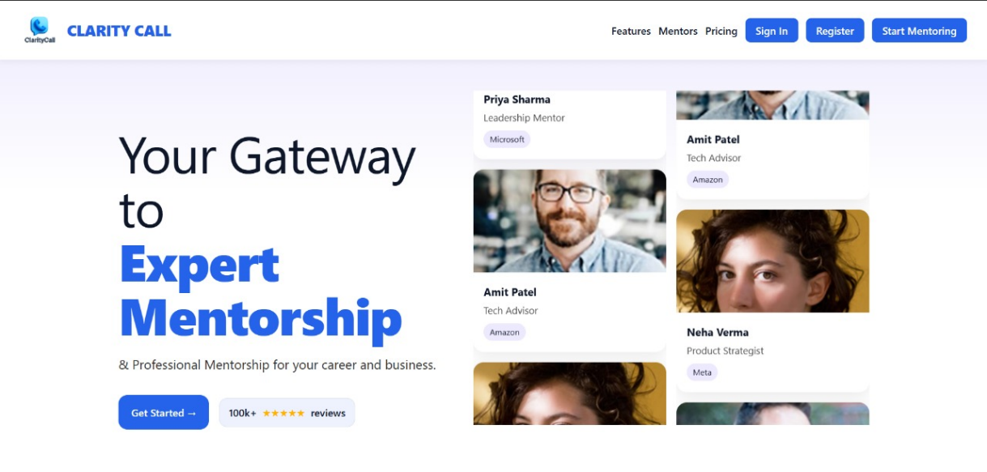
Figure 9.1: Landing Page

9.3.2 Registration Page for the user.
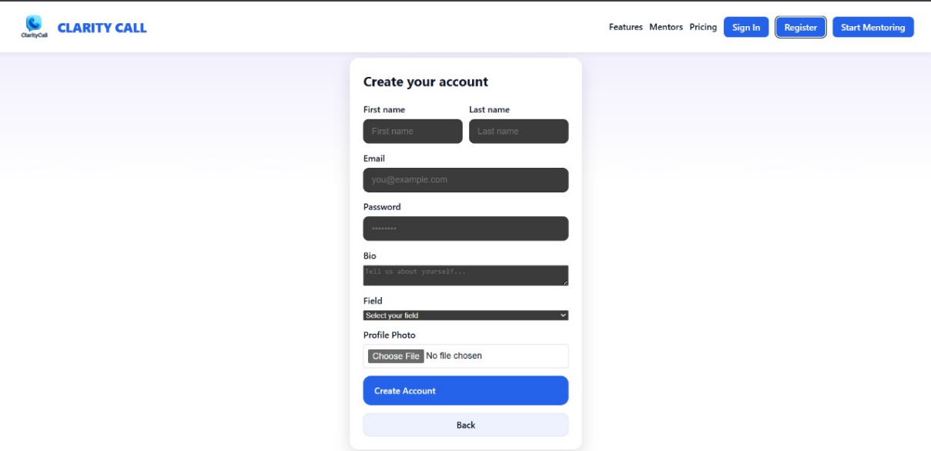

Figure 9.2: Registration Page

9.3.3 Login Screen for the user.

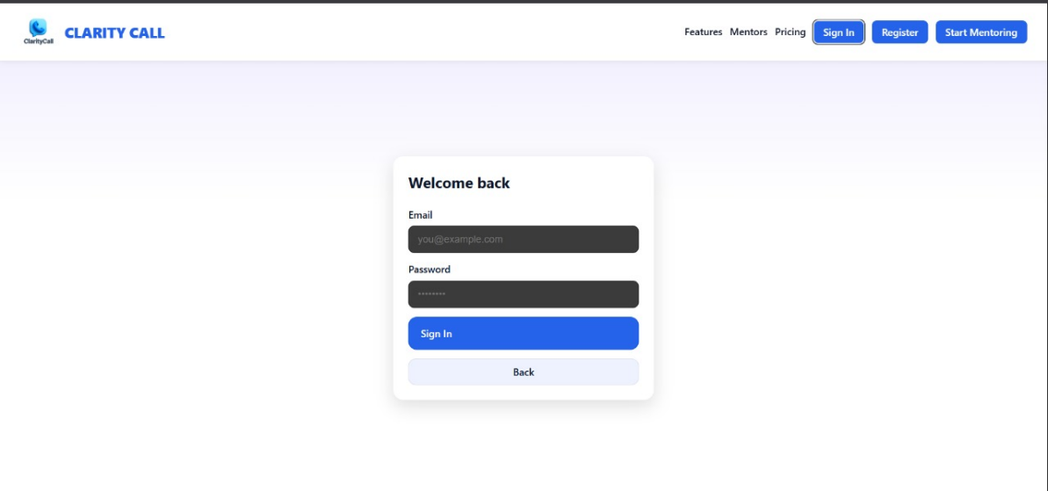

Figure 9.3: User Login Screen

9.3.4 Dashboard Screen for the mentor to track his earnings and sessions.

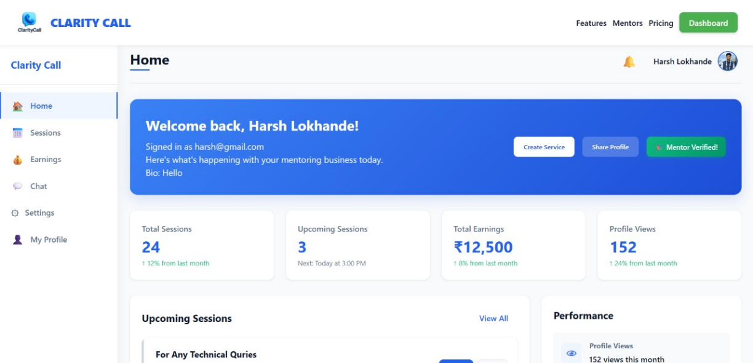

Figure 9.4: Mentor Dashboard

9.3.5 Dashboard for the mentee to his past sessions and other activities.

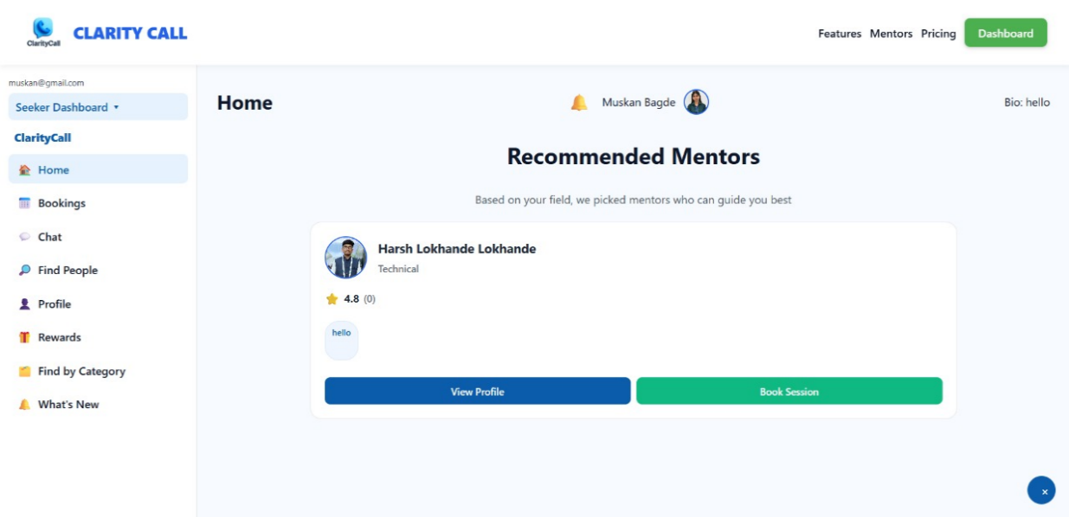
Figure 9.5: Mentee dashboard

9.3.6 Admin dashboard to track all the user and verifying the mentor applications.

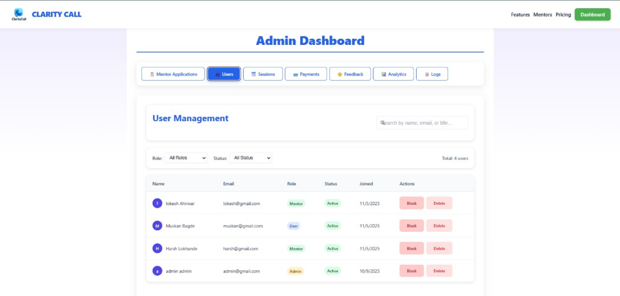

Figure 9.6: Admin dashboard

9.3.7 Chat screen for the mentor and mentee to chat.
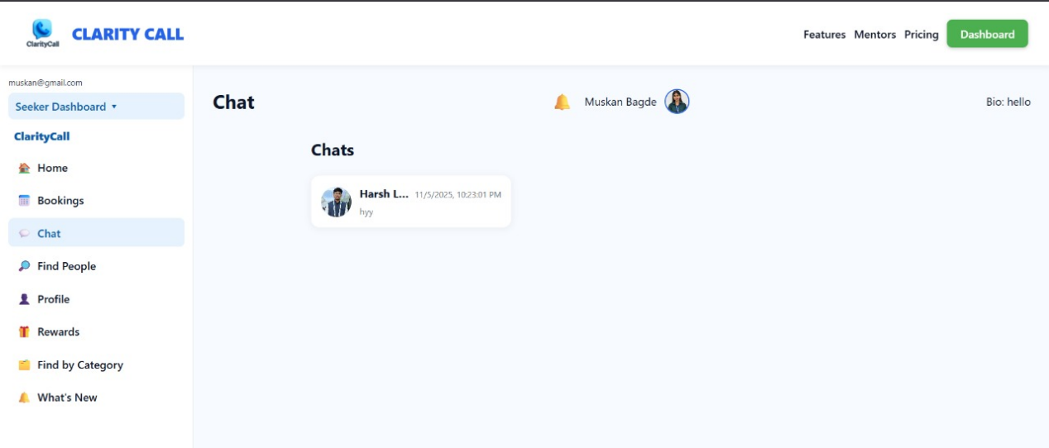
Figure 9.7: Chat screen between mentor and mentee

9.3.8 if someone wants to become mentor he/she will have to fill form.
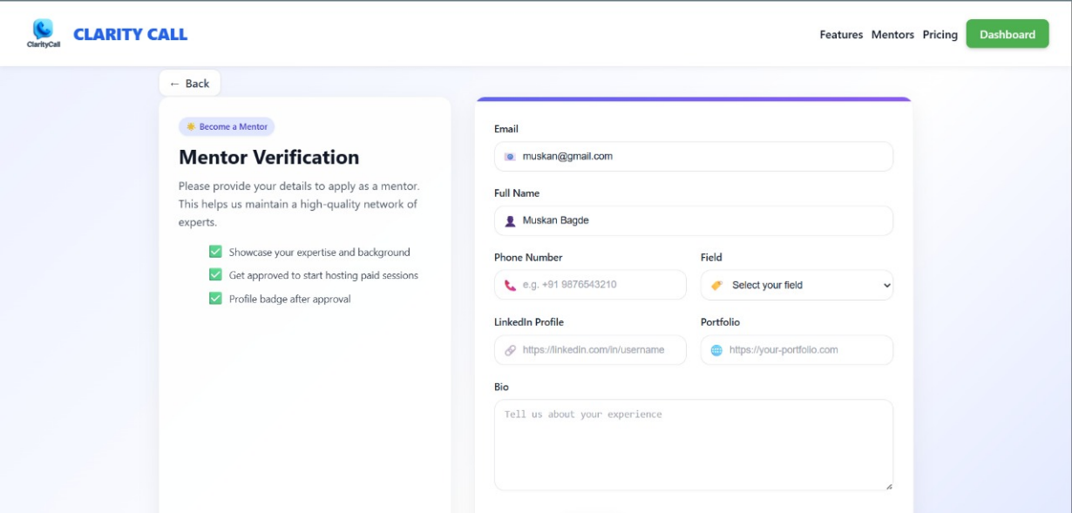
Figure 9.8: Mentor Verification Page

9.3.9 This is the booking section where mentor can see his/her all bookings.

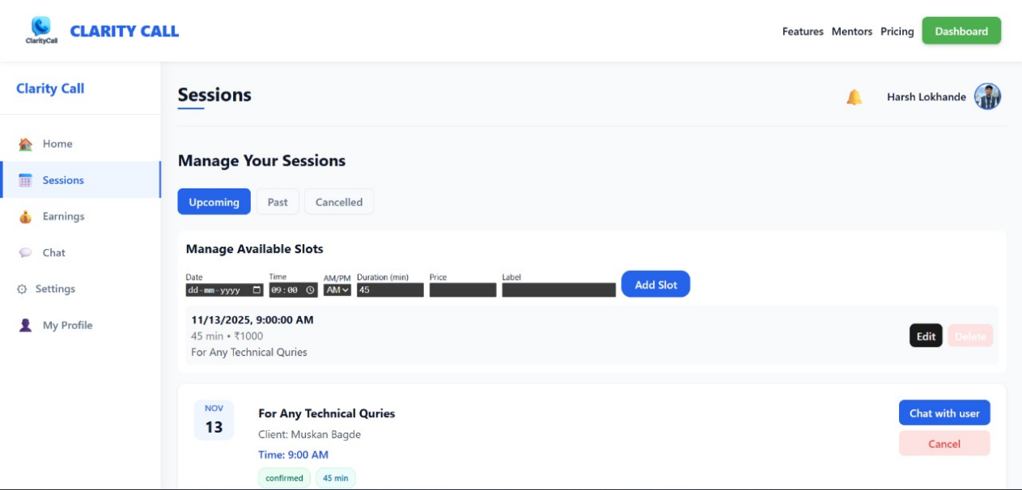

Figure 9.9: Mentor Booking Section

9.3.10 Mentee Profile screen where mentee can view his/her profile.

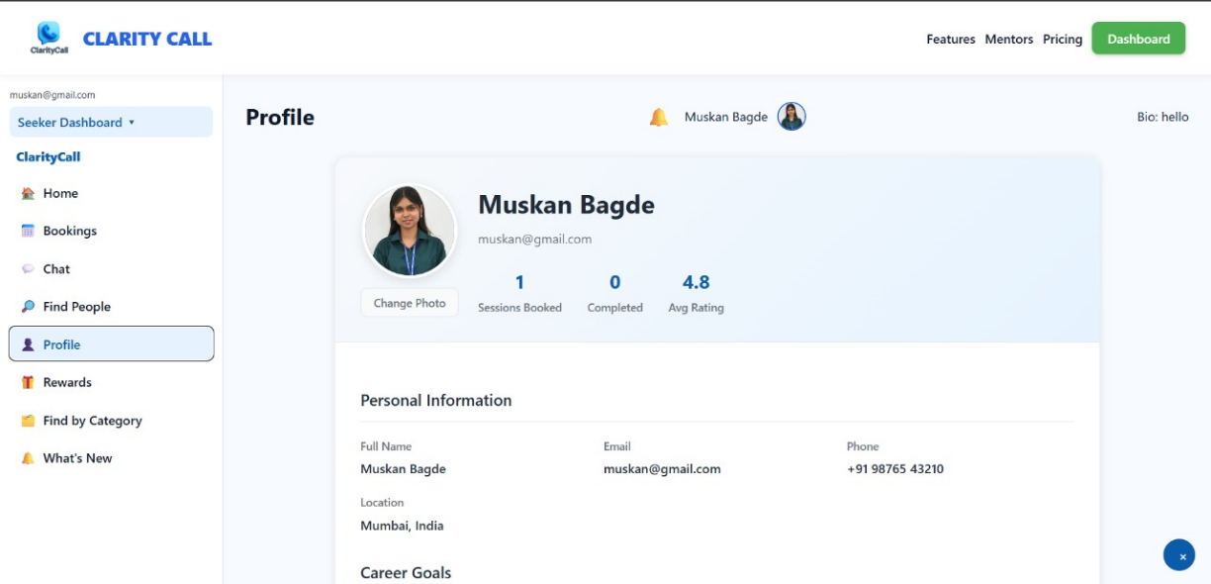

Figure 9.10: Mentee Profile Screen

9.3.11 App home screen.

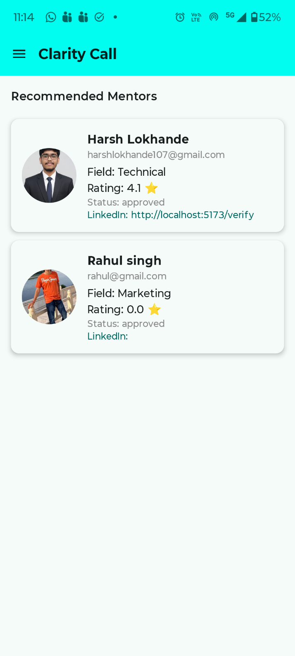

Figure 9.11: App Home Screen

9.3.12 App Menu screen.

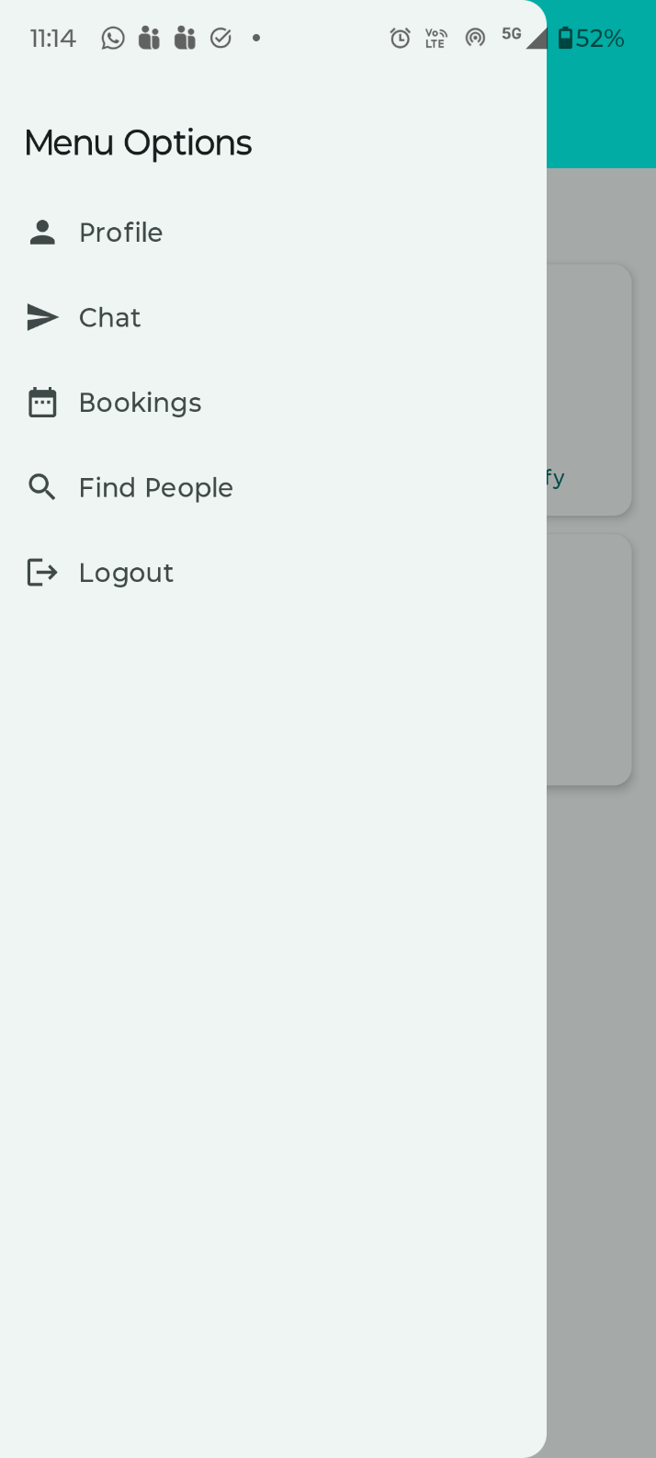

Figure 9.12: App Menu Screen

9.3.13 User Profile screen.

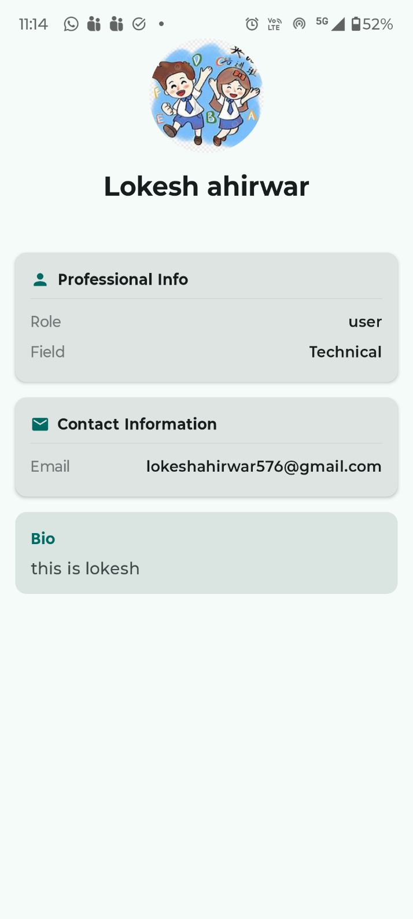

Figure 9.13:User Profile Screen

9.3.14 Sign Up screen.

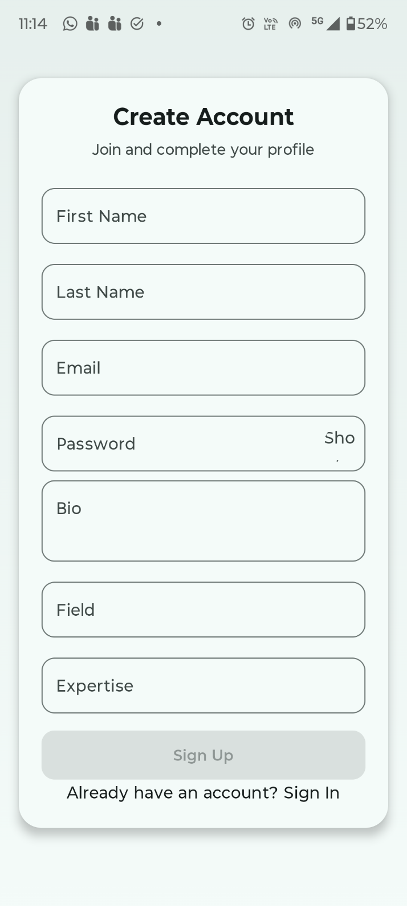

Figure 9.14:Sign Up Screen

.

Chapter 10
Conclusion And Future Work

CHAPTER 10

CONCLUSION ANDFUTURE WORK

10.1 Conclusion
Clarity Call effectively addresses the critical need for accessible, expert mentorship across various professional and personal domains. The platform combines user-friendly design with powerful features like intelligent mentor matching, automated scheduling, real-time video consultations, and flexible payment models. This provides a structured, secure, and scalable solution for both mentors and seekers to connect and collaborate. The system enhances learning, guidance, and career development opportunities, helping users achieve their goals efficiently. By integrating modern technologies and attending to user needs, Clarity Call stands as a comprehensive mentorship platform with significant potential impact.

10.2 Future Work
In the future, the platform can be strengthened by incorporating AI-driven mentor matching to provide more accurate, personalized pairing based on user goals and skill levels. The system can also introduce offline mentoring appointment booking, supported by automated SMS and email reminders to ensure users never miss their scheduled sessions. To expand its impact, the platform may collaborate with corporate and academic organizations to offer large-scale, managed mentorship programs. Additionally, extending compatibility to iOS devices, along with integrating multilingual support and accessibility features, will help make the platform more inclusive and widely usable. Engagement can be further improved through gamification elements such as badges, levels, and progress rewards. Finally, security can be enhanced by implementing encrypted session recordings, ensuring user privacy and safe data handling.

REFERENCES

WEBSITES (with exact URL up to page)
[ 1] Aggarwal, R. (2019). Building the Mentorship Marketplace: Lessons from India's Startup Ecosystem. Journal of Entrepreneurship, 28(2), 145-162.
[ 2 ] Official Android Development Guide: https://developer.android.com/guide
[ 3 ] Official Express Documentation: https://expressjs.com/
[ 4 ] Official MongoDB Documentation: https://www.mongodb.com/docs
[ 5 ] Official Jetpack Documentation: https://developer.android.com/jetpack/compose
[ 6 ] Topmate Website https://topmate.io/

PROJECT SUMMARY

ABOUT PROJECT
Title of the project | AI-POWERED EXPERT MENTORSHIP AND GUIDANCE HUB
Semester | 8th
Members | 4
Team Leader | Lokesh Ahirwar
Describe role of every member in the project | Lokesh Ahirwar : Android app development.  Distribution of work and among team members, Helping in project documentation.  Harsh Lokhande : Worked on Backend of the Project.  Muskan Bagde : Worked on Backend of the Project.  Jamil Akhtar : Worked on application UI.
What is the motivation for selecting this project? | Guidance is very important for growing fast in this fast growing technology world but finding the a good Mentor is very difficult. This gap is huge. To fill this gap between a Mentor and Mantee this platform is being developed.
Project Type  (Desktop Application, Web Application, Mobile App, Web) | React Web Application, Android App

Tools & Technologies

Programming language used | React, JavaScript, Node.js, Kotlin
Compiler used  (with version) | -
IDE used  (with version) | VS code, Android Studio
Front-End Technologies (with version, wherever Applicable) | React, Jetpack Compose, Kotlin
Back-End Technologies (with version, wherever applicable) | Express , Node.js
Database used  (with version) | MongoDB

Software Design& Coding

Is prototype of the software developed? | Yes
SDLC model followed (Waterfall, Agile, Spiral etc.) | Agile
Why above SDLC model is followed? | SDLC models are frameworks that guide development of software applications from conception to deployment and maintenance.
Justify that the SDLC model mentioned above is followed in the project. | Changing Requirements, Client Involvement, Iterative Development, Early Delivery of Value, Adaptability, Collaborate Team Environment, Continuous Testing, Risk Management, Customer Satisfaction.
Software Design approach Followed (Functional or Object Oriented) | Functional
Name the diagrams developed (According to the Design approach followed) | Use Case Diagram
In case Object Oriented approach is followed, which of the OOPS principles are covered in design? | -
No. of Tiers  (example 3-tier) | 3-tier
Total no. of front-end pages | Web – 3, app - 10
Total no. of tables in database | -
Database in which Normal Form? | -
Are the entries in database encrypted? | No
Front end validations applied  (Yes / No) | Yes
Session management done  (in case of web applications) | No
Is application browser compatible  (in case of web applications) | Yes
Exception handling done  (Yes / No) | Yes

Commenting done in code  (Yes / No) | YES
Naming convention followed  (Yes / No) | YES
What difficulties faced during deployment of project? | Challenges faced in developing the backend of the project and connecting the backend with the app. Making a web application with React technology.
Total no. of Use-cases | 3
Give titles of Use-cases | Mentor-Use case module, Mentee use case module, Admin use case module

Project Requirements

MVC architecture followed  (Yes / No) | Yes
If yes, write the name of MVC architecture followed  (MVC-1, MVC-2) | MVC - 2
Design Pattern used  (Yes / No) | NO
If yes, write the name of Design Pattern used | NO
Interface type  (CLI / GUI) | GUI
No. of Actors | 3
Name of Actors | Admin , Mentor, Mantee
Total no. of Functional Requirements | 11
List few important non- Functional Requirements | Security User-Friendly , Accuracy, Maintainability, Performance, Compatibility

Testing

Which testing is performed?  (Manual or Automation) | Manual
Is Beta testing performed for this project? | Yes

Write project narrative covering above mentioned points

Clarity Call is a mentorship platform designed to help individuals easily connect with expert mentors across various fields through efficient, real-time video consultations, guided by an intuitive interface, automated scheduling, and secure payment processing. It addresses common challenges in mentorship such as accessibility, scheduling conflicts, and quality assurance, offering features like intelligent mentor matching, feedback systems, and role-based dashboards. The software requirements emphasize both functional needs—like secure user authentication, profile management, session booking, communication tools, and payment integration—and non-functional needs such as fast response times, system availability, data security, and scalability. The platform fosters personal and professional growth by delivering expert guidance efficiently while maintaining user privacy and trust. Future enhancements can include AI-driven matching, offline booking with reminders, mentor certification, expanded platform compatibility, and gamification to increase user engagement and platform effectiveness.

Lokesh Ahirwar | 0187CS2221109 | Guide Signature  Dr. Komal Tahiliani
Harsh Lokhande | 0187CS2221088
Muskan Bagde | 0187CS2221127
Jamil Akhtar | 0187CS2221097

GLOSSARY OF TERMS

A
API Application Programming Interface - a set of functions for building software applications.

C
CRUD Create, Read, Update, Delete - basic operations of persistent storage.

D
DB Database - organized collection of data.

E
ER Create, Read, Update, Delete - basic operations of persiste Entity-Relationship - a data modeling technique that creates a graphical representation of entities and their relationships.

H
HTTPS Hypertext Transfer Protocol (Secure) - foundation of data communication for the web.

J
JSON Create, Read, Update, Delete - basic operations of persistent JavaScript Object Notation - a lightweight data interchange format.

M
MVVM Model-View-ViewModel - an architectural pattern used in software design.

O
OAuth Open Authorization - a standard for access delegation commonly used as a way to grant websites or applications access to user info

